

PRISM

(Find your next Fashion)

**CSC 310 – Fall 2020**

Course Name

**.team{**

**name: 404 Not Found;**

**}**

**dsd**

**Team Name**

**Team Member 1 – Shristi Chapagain  
Team Member 2 – Gyanendra Karn  
Team Member 3 – Trey Baus**

**Team Members**

We see PRISM as an alternative brand Fashion wear that will soon be one of the top fashion brands in the world that will still be approachable to everyone. These high-quality fashion wears are expensive because of its well renowned brands. We will provide the same high-quality fashion wear but will be ten times cheaper than their price. PRISM is for anyone from a newly born child to any age. It will make you look glamourous for any event anytime. This e-commerce website is a solution to that problem.

**Synopsis**

PRISM is a shopping website for shopaholics, general shoppers, and fashion admirers. The purpose of the project is to solve luxurious fashion problem. We know the brands like Gucci, D&G, Bloomingdale, Ralph Lauren, Louis Vuitton, etc. are luxurious brands that are expensive as heck. We, at PRISM, offer the same luxurious fashion wear at reasonable amount. We, as a Fashion is approachable to everyone in every season. PRISM is a project that will bring fashion to everyone.

**Purpose**

Executive Summary

# Background

The purpose of the project is to solve luxurious fashion problem. We know the brands like Gucci, D&G, Bloomingdale, Ralph Lauren, Louis Vuitton, etc. are luxurious brands that are expensive and have been since long time. We, PRISM, comes in the play to help support fashion. This project is for everyone from a newly born child to any age.

**Problem**

# Project Plan

* Milestone 1: 

Make a contract, repository and teams in GitHub

* Milestone 2: 

Plan what your final project will looks like

Create a site map

Create a planning document

* Milestone 3: 

Creating the look-and-feel of the project

Planning the graphical layout and placement of major and minor components, as well as the logical flow or transition from one component to another.

**Milestone Summary**

Milestone 1

* Team Lead: Shristi
  + Made a contract
  + Created a repository in GitHub
  + Created teams for the group

Milestone 2

* Team Lead: Gyanendra Karn
  + Created a site map: Gyanendra Karn
  + Planning document: Shristi Chapagain
  + Created subdomains and FTP Accounts
* Site Map:

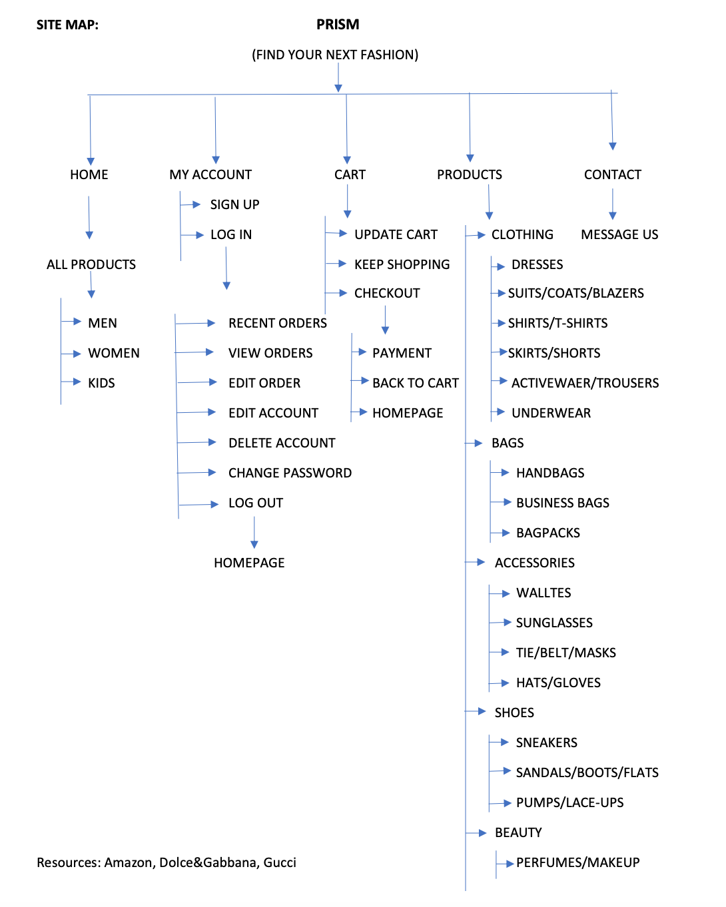

**Milestone 1 and 2 Details** With others it would be  somewhere where they can talk to their  friends for fun.**ls**

Milestone 3

* Team Lead: Trey Baus
  + Everyone was assigned some pages to design, and the overall logical flow was discussed.
  + Shristi: Login, Contact Us, Product Listing, Settings
  + Trey: Product details, admin product details, cart, your order page
  + Gyanendra: Homepage, Admin Page, Admin Item List, Admin_user_maintain page

Shristi Chapagain:

Login Page:



Allows the user to sign-in in their account or signup if they haven’t already!

**Milestone 3 Details** With others it would be  somewhere where they can talk to their  friends for fun.**ls**

Product Listing Page:



Lists out all the available products from the selected category, also allowing the user to filter the type of products.

**Milestone 3 Details** With others it would be  somewhere where they can talk to their  friends for fun.**ls**

Contact Us Page:



Allows users to contact the admin of the website.

**Milestone 3 Details** With others it would be  somewhere where they can talk to their  friends for fun.**ls**

User Account Settings:



Allows the user to change their username, passwords, and other information about them.

**Milestone 3 Details** With others it would be  somewhere where they can talk to their  friends for fun.**ls**

Gyanendra Karn:

Homepage:

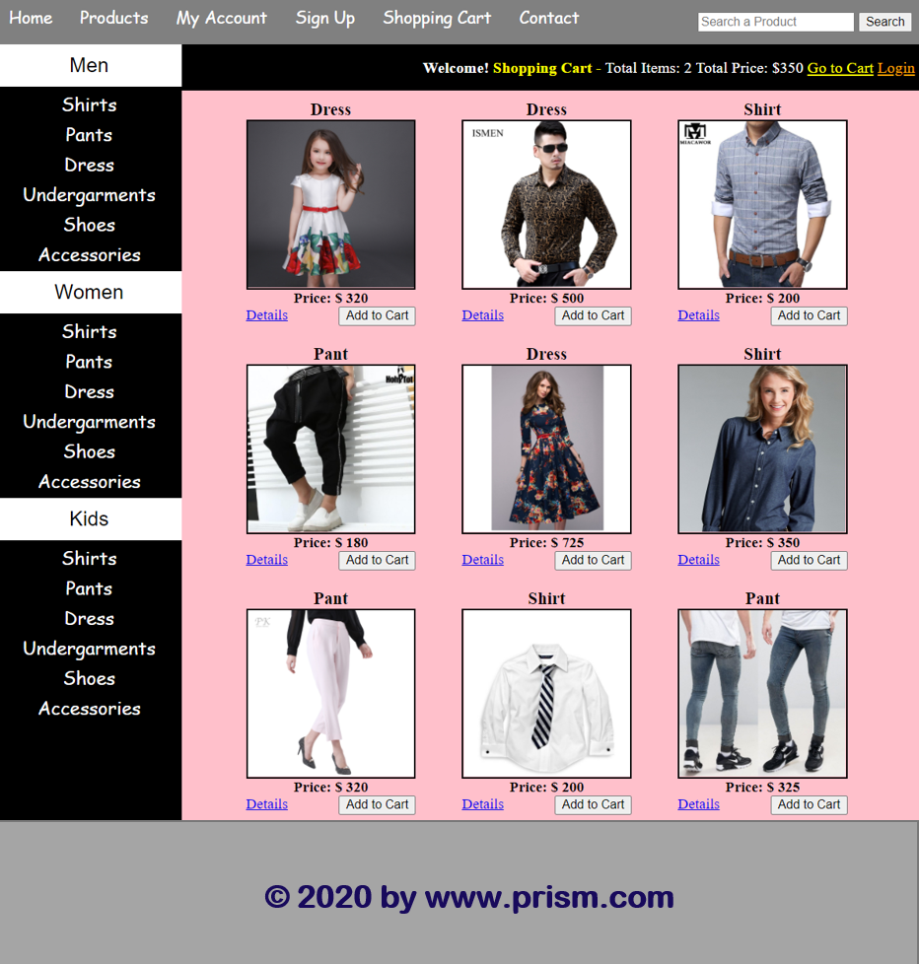

Homepage, where you can view, select, add to cart, filter based on your selection, etc. This is just a prototype, will be a lot cooler.

**Milestone 3 Details** With others it would be  somewhere where they can talk to their  friends for fun.**ls**

Admin Page:

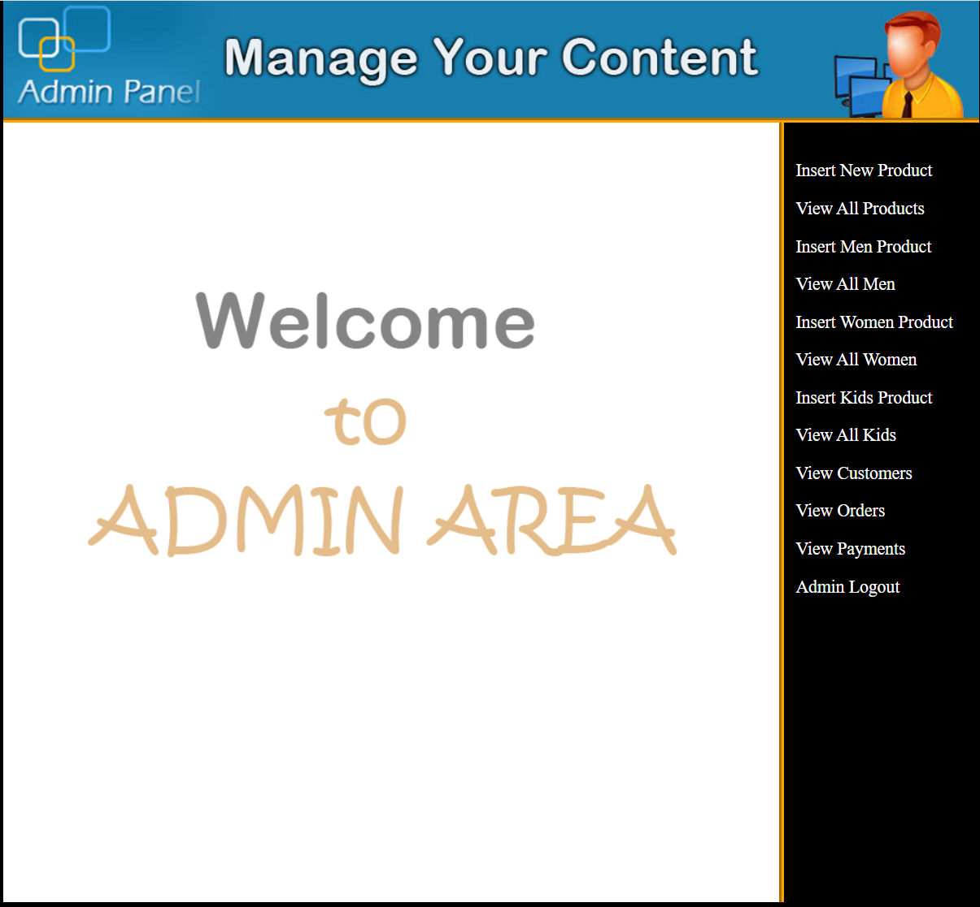

Admin area, where all contents like users, products, etc. can be managed.

**Milestone 3 Details** With others it would be  somewhere where they can talk to their  friends for fun.**ls**

# Project Resources

|  |  |  |
| --- | --- | --- |
| Date | Name/URL | Note |
| 10/29/2020 | [www.amazon.com](http://www.amazon.com)  [www.dolceandgabbana.com](http://www.dolceandgabbana.com)  [www.gucci.com](http://www.gucci.com) | Idea of the flow and designs taken from amazon. |

Admin Item Lists:

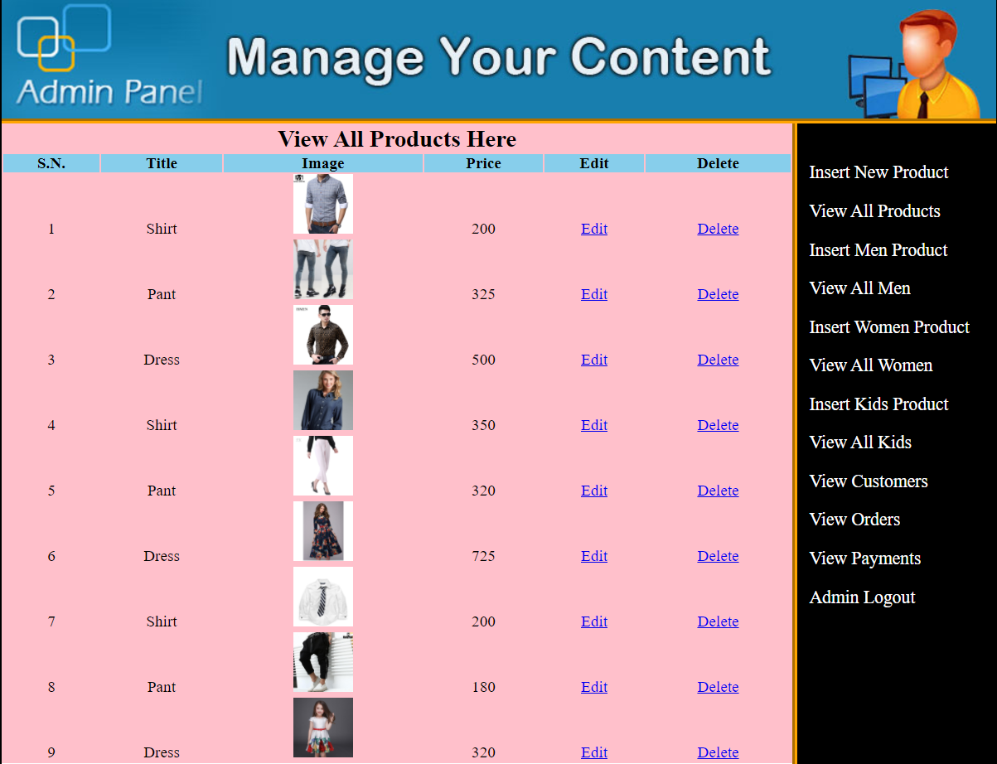

Admin Item List, where all the product items can be managed. It can be edited and deleted.

**Milestone 3 Details** With others it would be  somewhere where they can talk to their  friends for fun.**ls**

Admin User Maintain:

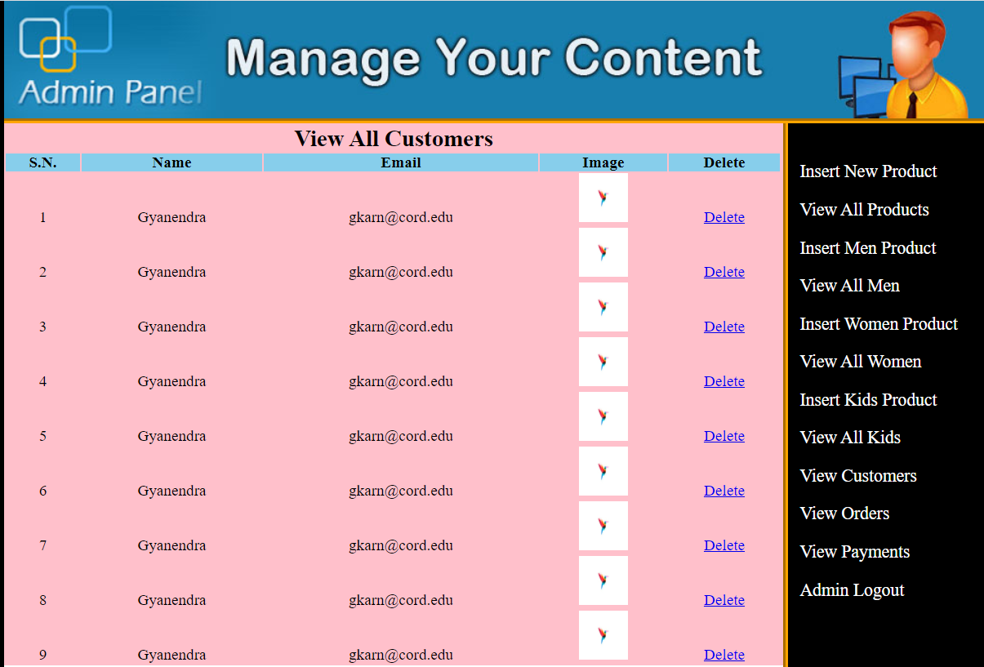

Maintaining customer account, admin can delete customer account if the user is a bad guy.

**Milestone 3 Details** With others it would be  somewhere where they can talk to their  friends for fun.**ls**

Trey:

Product Details:

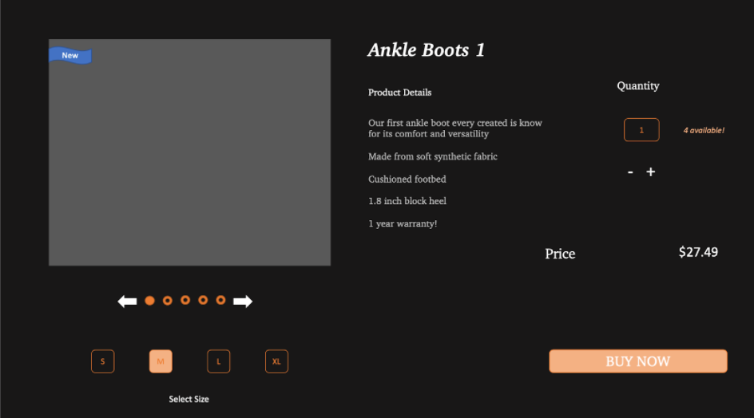

This slide is the user product details slide. The user will be able to cycle through photos of the product, then be able to select the size and quantity they would like to purchase based on availability. This slide gives more detailed information on the product as well as the price and the option to “buy now” or “add to cart”

**Milestone 3 Details** With others it would be  somewhere where they can talk to their  friends for fun.**ls**

Admin Product Details:

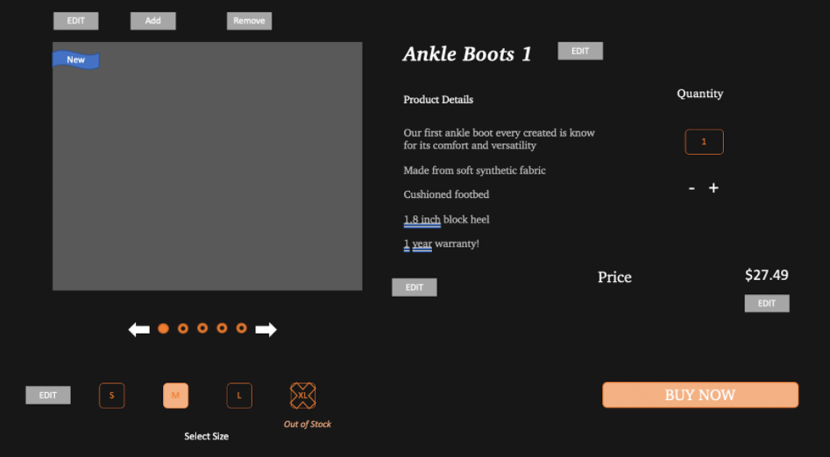

This slide is the admin product details page. This is the same page as the user details except the admin only has access to this version as they will be able to edit the price, the size options/availability, product details, product name, and lastly be able to add or remove photos of the product or even add other info via the edit button such as mark a product as sold out or new to the site.

**Milestone 3 Details** With others it would be  somewhere where they can talk to their  friends for fun.**ls**

Cart:

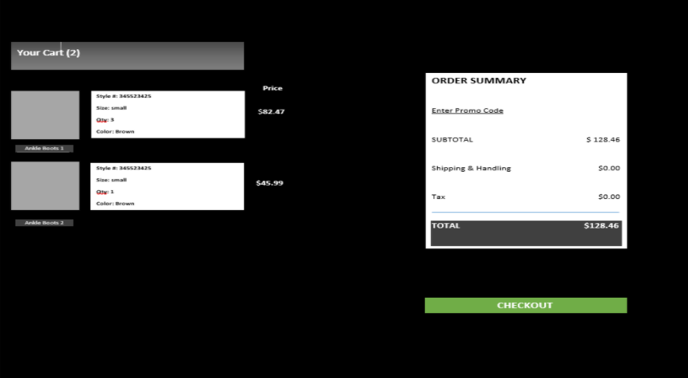

This is a very simple cart page showing each item a customer adds to their cart, the price of that product, and a few important details of each item. This page also shows the order summary directly before the customer makes a purchase allowing them to enter a promo code if they choose, also can view the subtotal before taxes and shipping/handling. Finally, the summary gives the final total of the order and the option to checkout the items.

**Milestone 3 Details** With others it would be  somewhere where they can talk to their  friends for fun.**ls**

Your Orders page:

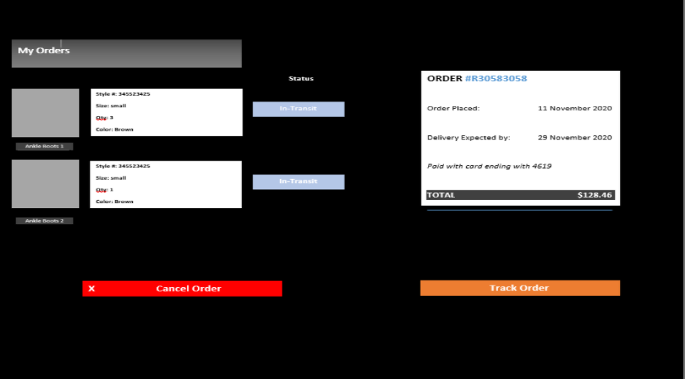

This is the “my orders” page which will allow a customer to view an order they had just completed. They will be able to click on the track order button which will give them updates on where their package is. They will also have the option to cancel their order (within a certain amount of time maybe?). This page also gives the status of the shipment as well as an overview of each item purchased including a less detailed product description of each item. Lastly, this page shows the date the order was placed, the date it is expected to arrive, and the last 4 numbers of the card used to make the purchase.

**Milestone 3 Details** With others it would be  somewhere where they can talk to their  friends for fun.**ls**

**Work Plan:**

